Tricia Martineau Wagner, a nationally renowned author & presenter, is an experienced elementary teacher and reading specialist. As a well versed and entertaining speaker she brings books to life! Ms. Wagner enjoys conducting classroom presentations for grades K - 8.

“North Carolina, the First Golden State” child-interactive presentation:

The author will:

- Come dressed in gold miner’s costume
- Give history of America’s two big gold rushes (1799 and 1849)
- Bring gold mining artifacts to handle
- Demonstrate how to pan for gold
- Allow students to pan for gold (depending on assembly size)
- Read excerpts from her book
- Inspire students to read and write
- Explain how a book is published
- Q & A

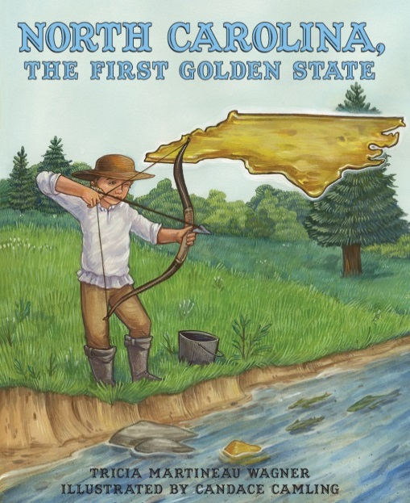

BOOK SIGNING: Book order forms will be sent home prior to the event. Ms. Wagner will bring the personally autographed books to your school. (Late book orders are always accepted.) An autographed book will be gifted to your school library.

Number of presentations in one school visit: up to 4

Large school assembly: Small group assembly:
(200 students) 60 minutes (60 students) 60 minutes

$300 for the 1st presentation $200 for the 1st presentation
$300 for the 2nd presentation $200 for the 2nd presentation
$200 for the 3rd presentation $175 for the 3rd presentation
$200 for the 4th presentation $175 for the 4th presentation

Visit Ms. Wagner’s website: www.authortalk.org.
For additional information or to schedule an event please contact the author directly: tricia@authortalk.org

Additional program presentations that coordinate with Ms. Wagner’s other books include:
50 Wacky Things Animals Do / It Happened on the Oregon Trail / It Happened on the Underground Railroad / African American Women of the Old West / Black Cowboys of the Old West. [The author also conducts a hands-on, experiential based program: A Child’s Life out West.]

Thank you in advance for forwarding this educational opportunity to other schools/educators.

